** ALINYIIKIRA JUNIOR SCHOOL - NAKWERO**

**BEGINNNING OF TERM III EXAMINATIONS 2024**

**AGE GROUP: 5 – 6 YEARS**

**CLASS: TOP**

**SUBJECT: SOCIAL DEVELOPMENT (LA 1)**

NAME:…………………………………………………………………..……

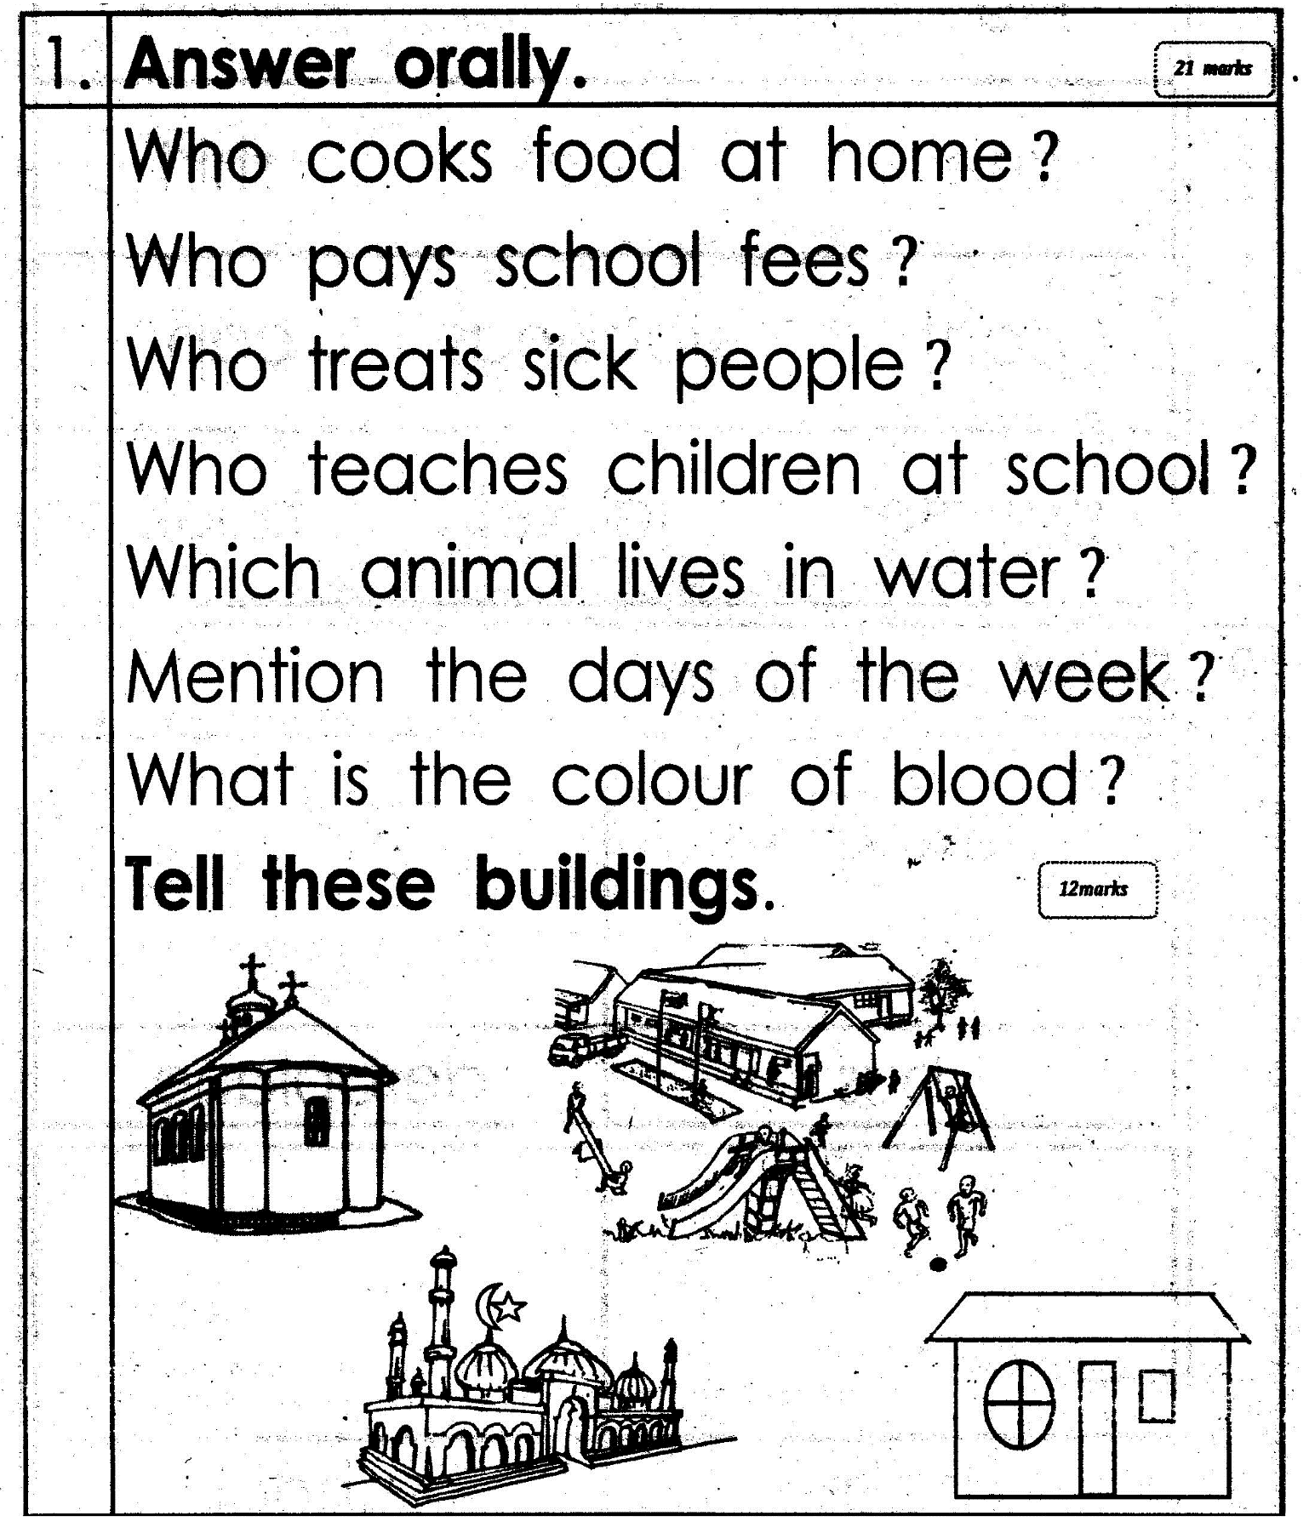

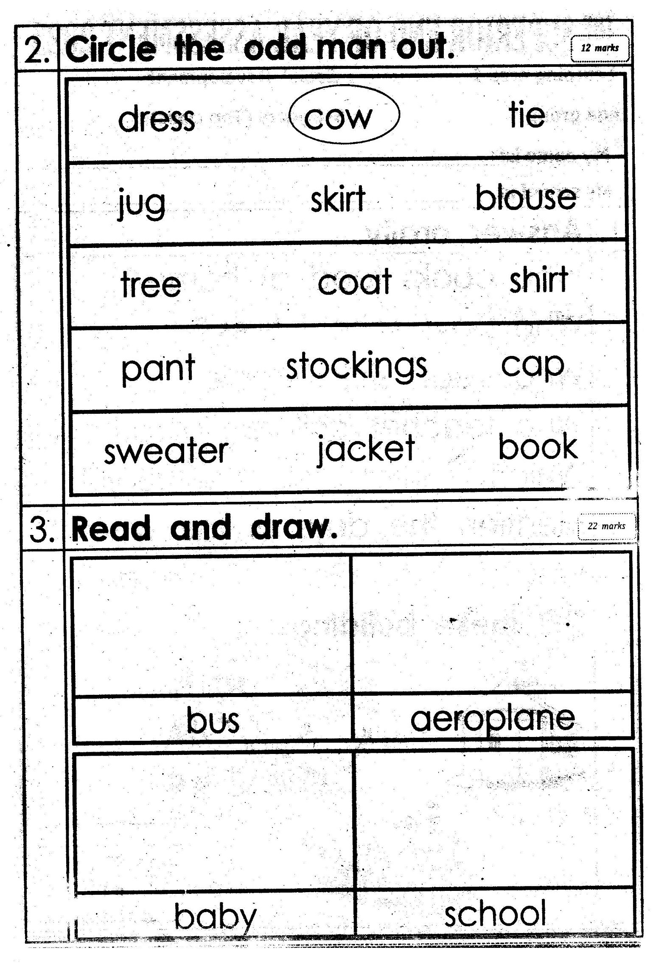

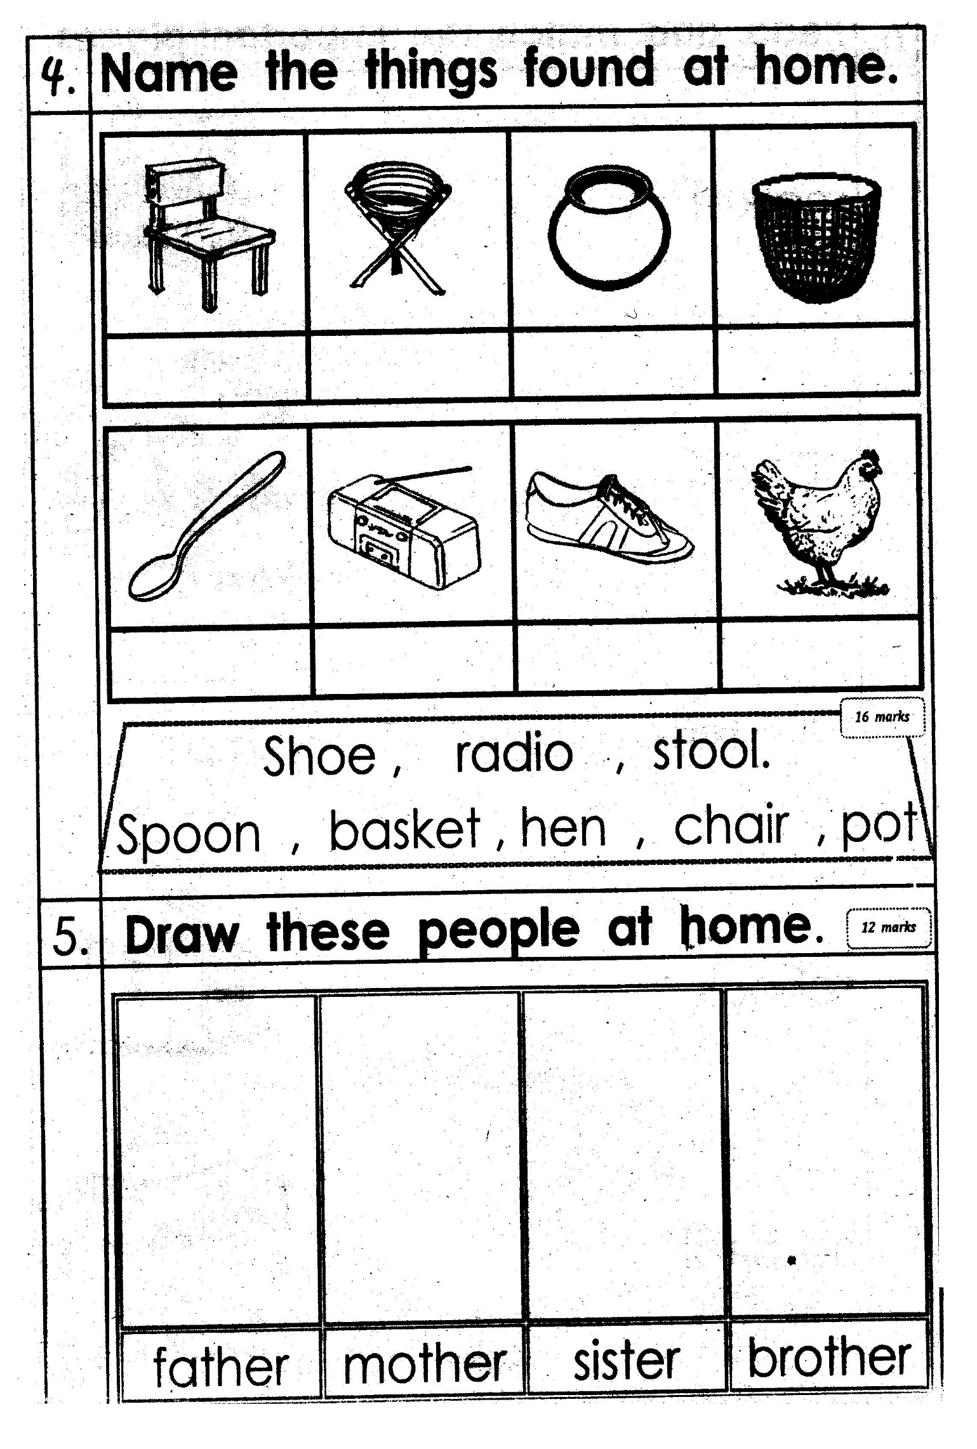

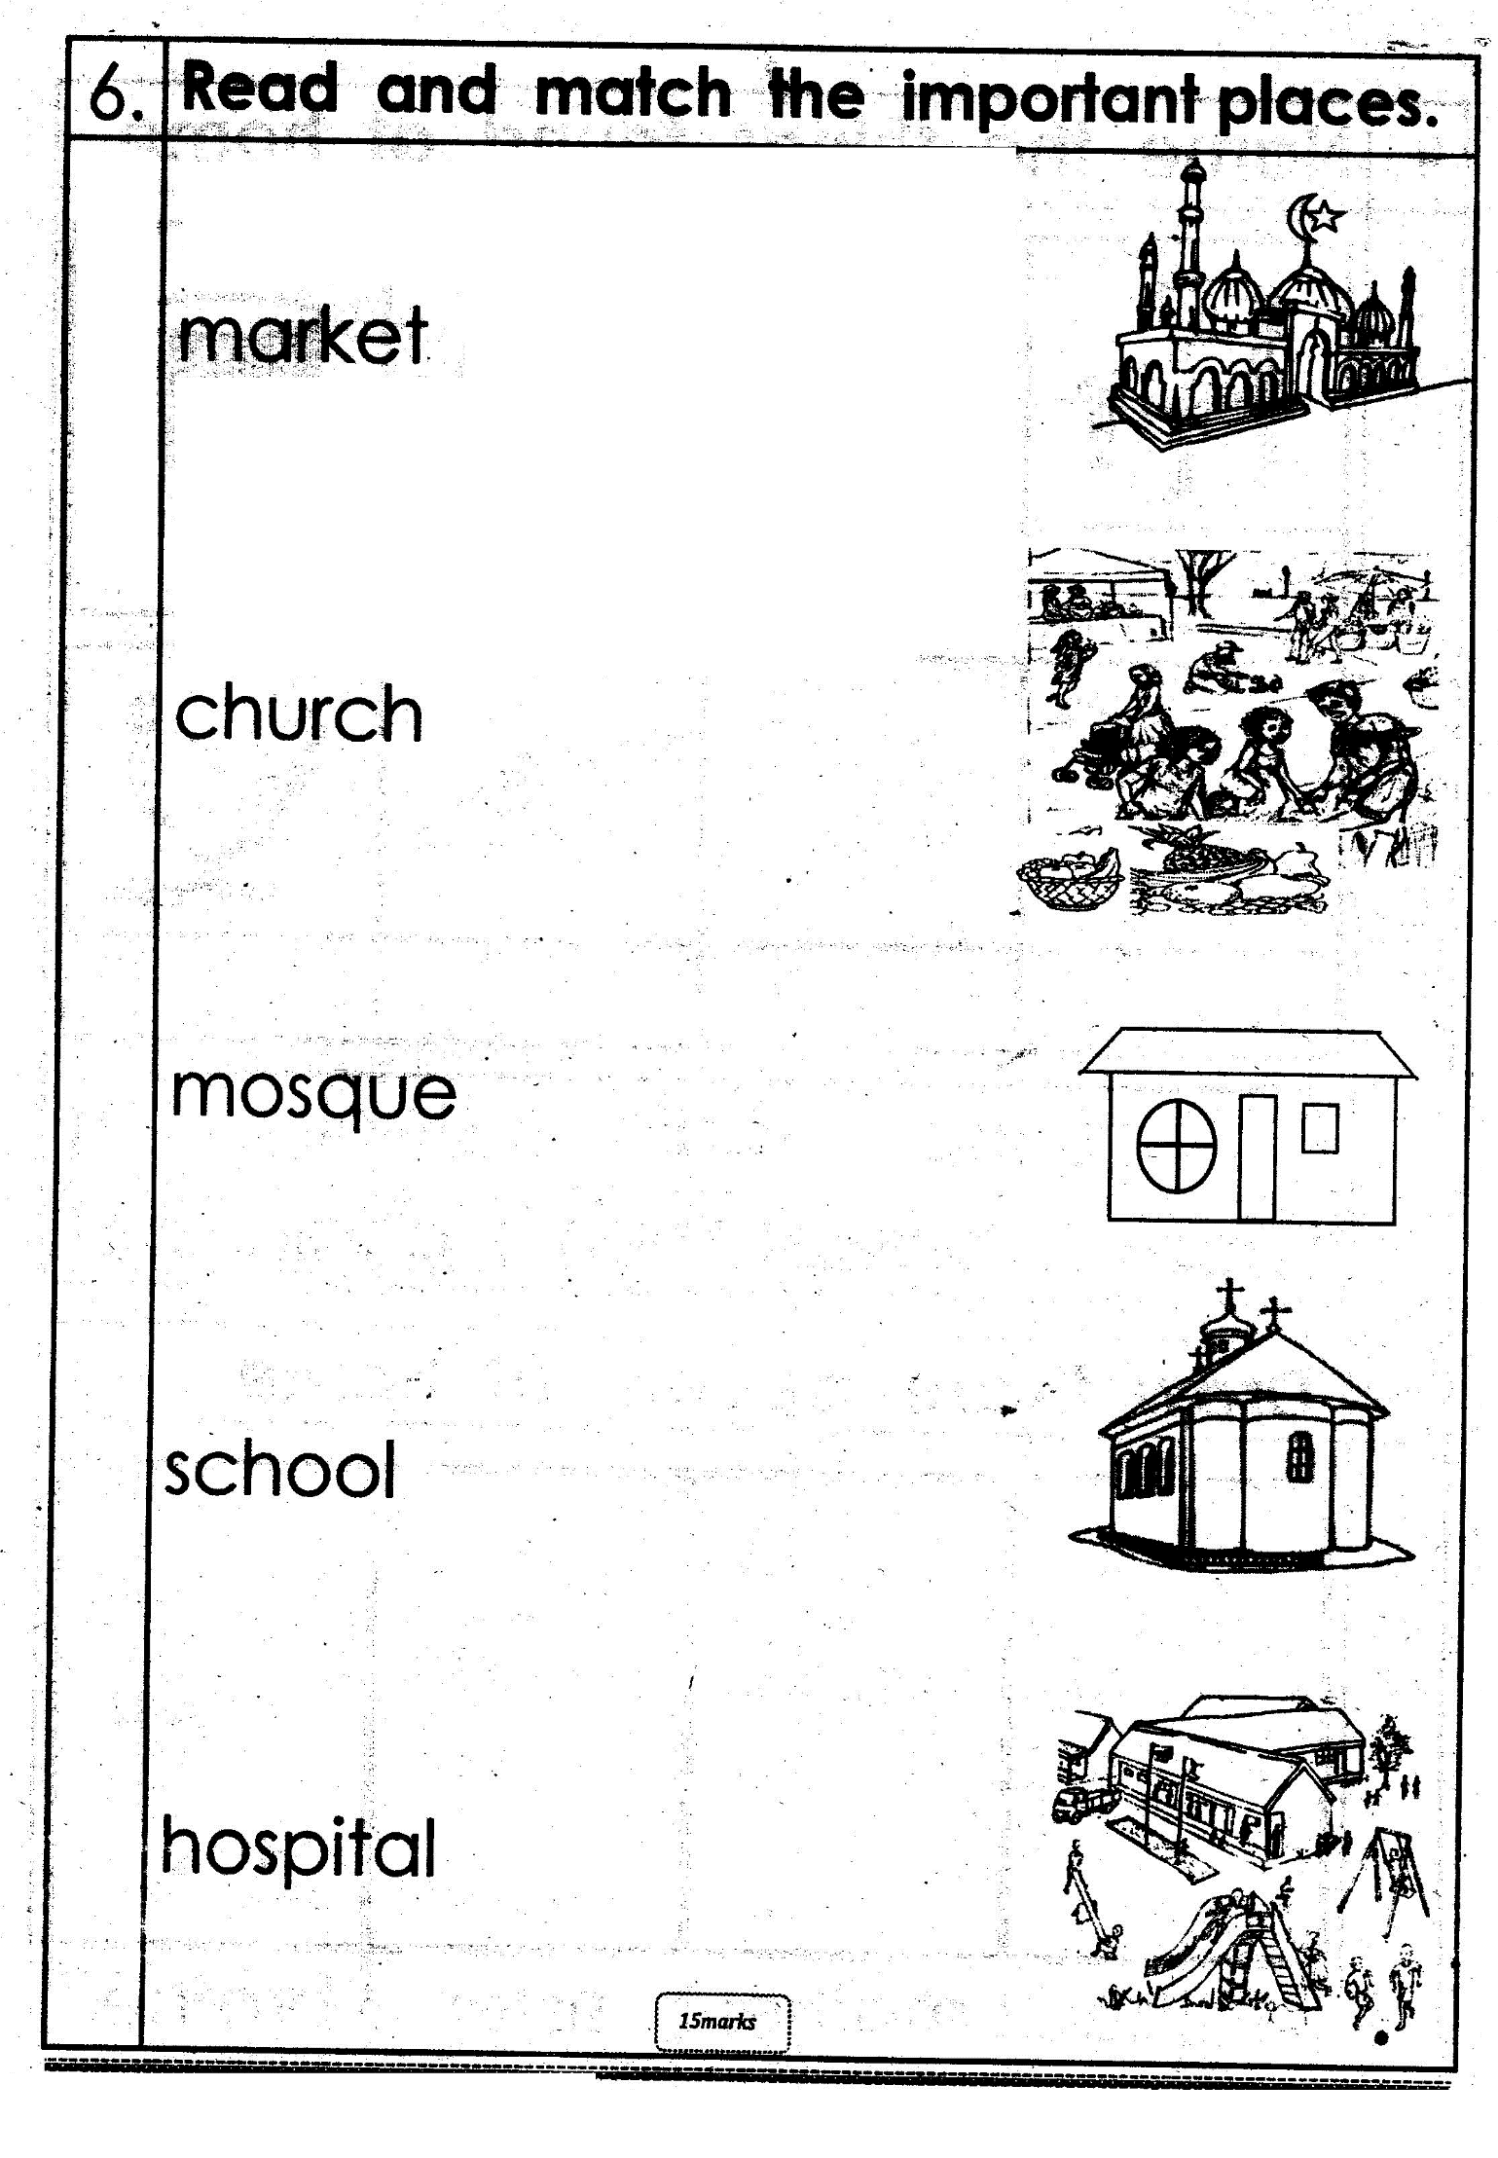

**7. Answer orally:**

Who cooks food at home?

Who pays school fees?

Who teaches children at school?

Who treats sick people?

Mention the days of the week.

How many months make a year?